# Task For DevOps

1. Installation of Java is required for Jenkins

**Command:**

sudo apt update

sudo apt install fontconfig openjdk-17-jre

java -version

openjdk version "17.0.13" 2024-10-15

OpenJDK Runtime Environment (build 17.0.13+11-Debian-2)

OpenJDK 64-Bit Server VM (build 17.0.13+11-Debian-2, mixed mode, sharing)

**ScreenShot:**

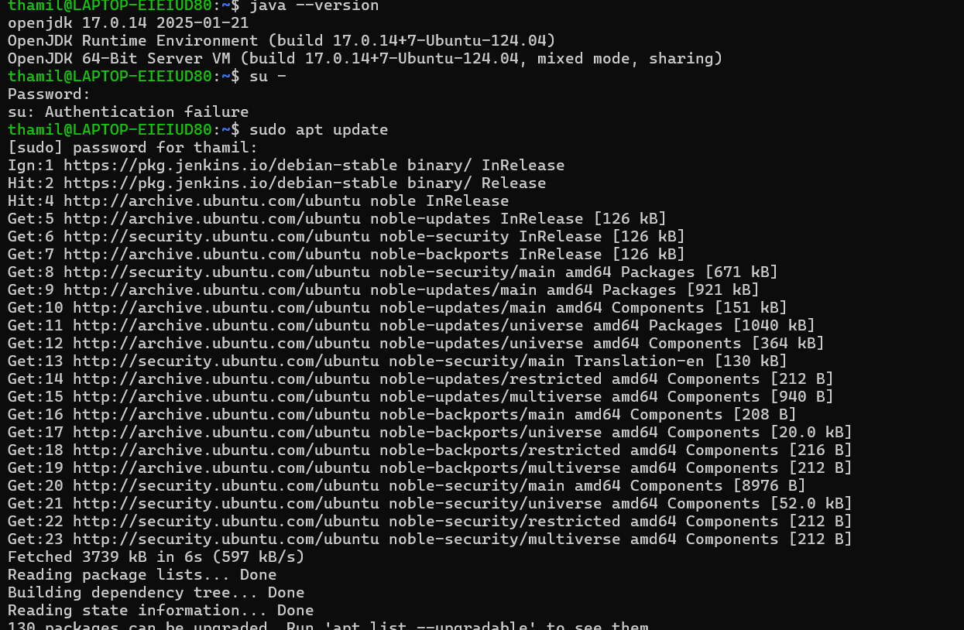

The Java JDK has been successfully installed

1. Install Jenkins

**Command:**

sudo wget -O /usr/share/keyrings/jenkins-keyring.asc \

https://pkg.jenkins.io/debian-stable/jenkins.io-2023.key

echo "deb [signed-by=/usr/share/keyrings/jenkins-keyring.asc]" \

https://pkg.jenkins.io/debian-stable binary/ | sudo tee \

/etc/apt/sources.list.d/jenkins.list > /dev/null

sudo apt-get update

sudo apt-get install Jenkins

**ScreenShot:**

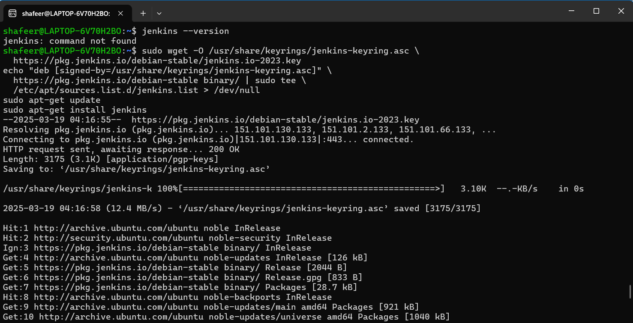

JenKins has been successfully installed

Now, Go to the Jenkins page in the Browser running in Localhost:8080 and login with your credentials

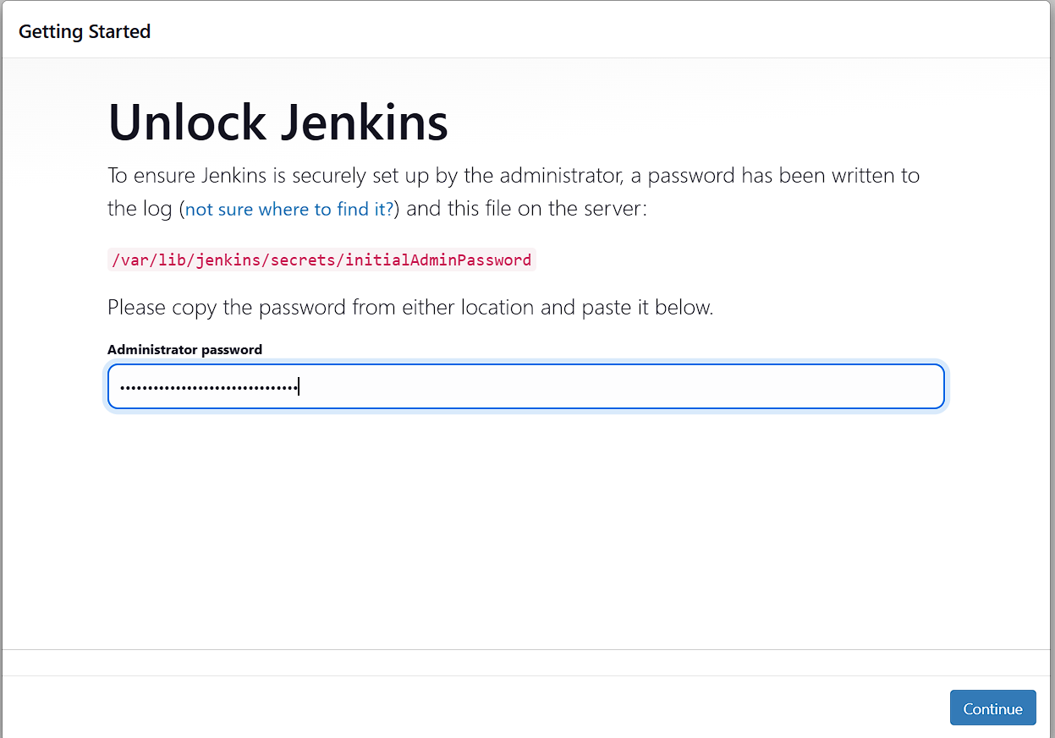

Install the Suggested plugins required

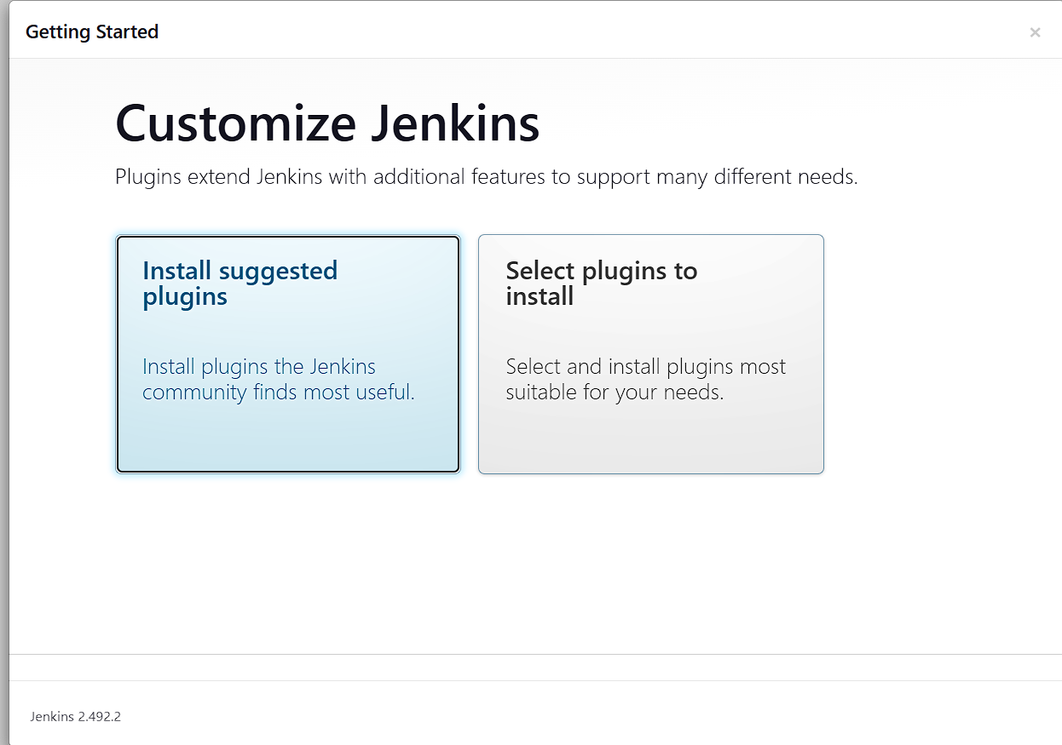

Now Jenkins is ready to use

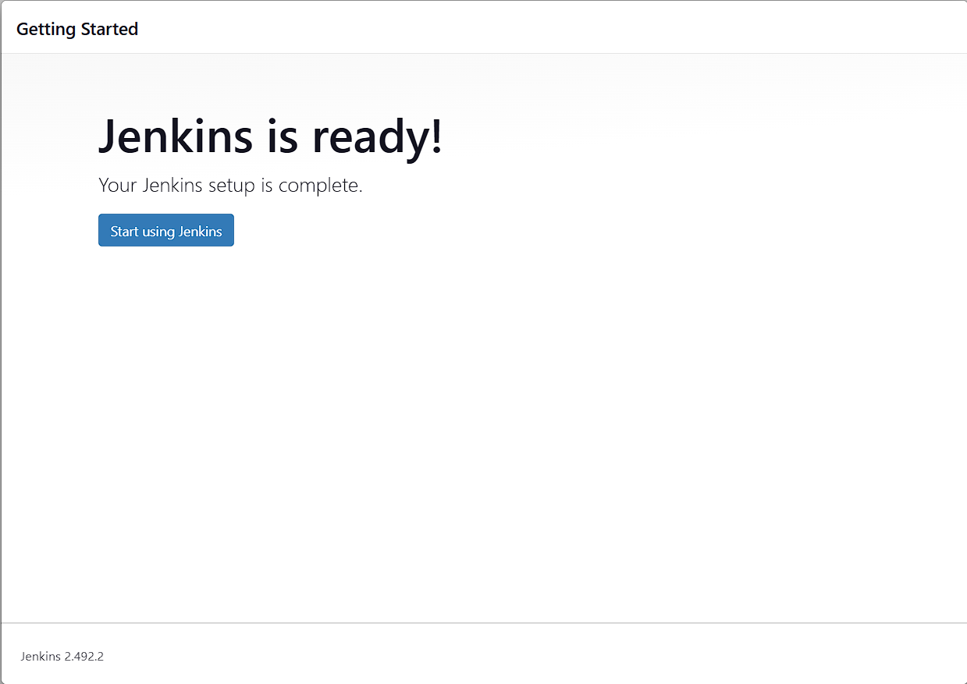

Now create a new item

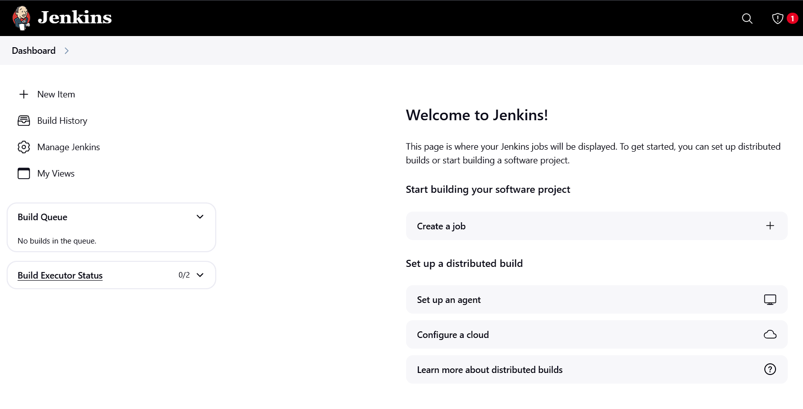

Give an item name and select the item type as free-style project

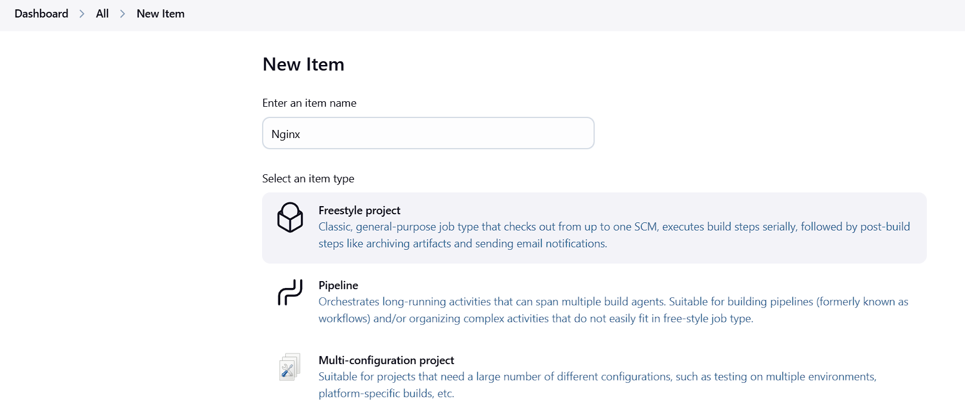

Build the steps using the commands

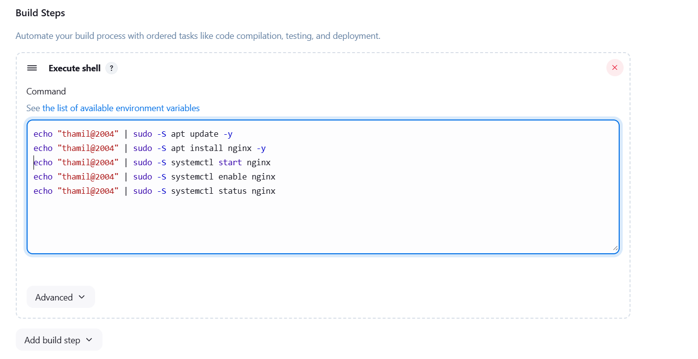

After the successful compilation of the build, Nginx will be opened in localhost, once the ip address is given

